‘There’s No Place for Them to Go’: I.C.U. Beds Near Capacity Across U.S.

*In terms of the coronavirus, they’re a theater of American disgrace.*

By Lauren Leatherby, John Keefe, Lucy Tompkins, Charlie Smart and Matthew Conlen   
Dec. 10, 2020

In El Paso, hospitals reported that just 13 of 400 intensive care beds were not occupied last week. In Fargo, N.D., there were just three. In Albuquerque, there were zero.

More than a third of Americans live in areas where hospitals are running critically short of intensive care beds, federal data show, revealing a newly detailed picture of the nation’s hospital crisis during the deadliest week of the Covid-19 epidemic.

Hospitals serving more than 100 million Americans reported having fewer than 15 percent of intensive care beds still available as of last week, according to a Times analysis of data reported by hospitals and released by the Department of Health and Human Services.

Many areas are even worse off: One in 10 Americans — across a large swath of the Midwest, South and Southwest — lives in an area where intensive care beds are either completely full, or fewer than 5 percent of beds are available. At these levels, experts say maintaining existing standards of care for the sickest patients may be difficult or impossible.

“There’s only so much our frontline care can offer, particularly when you get to these really rural counties which are being hit hard by the pandemic right now,” said Beth Blauer, director of the Centers for Civic Impact at Johns Hopkins University.

Sharp increases in Covid-19 patients can overwhelm smaller hospitals, she said. “This disease progresses very quickly and can get very ugly very fast. When you don’t have that capacity, that means people will die.”

The new data set, released on Monday, marks the first time the federal government has published detailed geographic information on Covid-19 patients in hospitals, something public health officials have long said would be crucial to responding to the epidemic and understanding its impact.

Hospitalization figures collected by the Covid Tracking Project show that the number of people hospitalized with the virus nationwide has doubled since the beginning of November. But existing state-level figures have obscured vast differences within states, making it difficult to recognize local hot spots.

The new data shows that some areas — like Amarillo, Texas, Coral Gables, Fla., and Troy, Mich. — are seeing rates of serious illness from Covid-19 that approach the levels seen in New York City during the worst weeks of the spring.

Political leaders in many states are ramping up measures to try to slow the spread. Last week, California issued stay-at-home orders for regions where hospitals surpassed 85 percent intensive care occupancy. Gov. Michelle Lujan Grisham of New Mexico, where I.C.U.s are full across the state, is expected to soon announce that hospitals can ration care based on who is most likely to survive.

Doctors and researchers said the shortages are already causing serious damage.

At two hospitals in rural Georgia, officials have expanded the numbers of critical care beds to a total of 30, but on most days lately, all of them are full. Administrators spend hours worrying about how best to juggle the numbers so that no patient is left without proper care.

“22 hours out of 24,” Deborah Matthews, the chief nursing officer for the Tanner Health System, said when asked how much time she is spending worrying about capacity issues. Although Covid-19 patients are by no means the only ones being treated in the hospitals, the added numbers from the virus have stressed the system.

“The worry is what are you going to do with the 31st I.C.U. patient? What are you going to do with the next patient who needs to be on a ventilator?” she said. “You have contingency plans for all of that, but you are just constantly thinking about those things.”

Both hospitals, in Carrollton and Villa Rica, have been operating at more than 100 percent capacity, according to the new federal data set.

The hospitals serve relatively small communities where many of the medical staff know the patients, so they push themselves to provide the care needed, said Loy Howard, the president of Tanner Health System. “There is not a lot of wiggle room,” he said, “I have been doing this for 35 years and I have not seen this kind of wear and tear on the staff.”

In North Dakota, which for weeks this fall had the worst rate of infection per capita in the country, the number of unoccupied I.C.U. beds across the whole state at times dipped into the single digits in early November. In the small city of Minot, the hospital, Trinity Health, devoted more than an entire floor of its six-floor hospital to coronavirus patients.

Other North Dakota hospitals would normally accept transfers to help ease the burden, but when Dr. Jeffrey Sather, chief of medical staff, called around for help, he found that everywhere else was also full.

Patients kept coming, piling up in his emergency room. “There’s no place for them to go,” he said at the time.

Survival rates from the disease have improved as doctors have learned which treatments work. But hospital shortages could reverse those gains, risking the possibility of increasing mortality rates once again as patients cannot receive the level of care they need.

Thomas Tsai, an assistant professor of health policy at Harvard University, said that when resources are critically constrained, health care workers already facing burnout are forced to make emotionally wrenching decisions about who receives care.

There is some evidence physicians are already limiting care, Dr. Tsai said. For the last several weeks, the rate at which Covid-19 patients are going to hospitals has started decreasing. “That suggests that there’s some rationing and stricter triage criteria about who gets admitted as hospitals remain full,” he said.

In California, where a shortage of hospital beds triggered a lockdown in much of the state by Monday, hospital workers are bracing for the next few months. More than 10,000 Covid-19 patients are now hospitalized in the state, more than 70 percent above levels of two weeks ago, and the effects of the Thanksgiving holiday may not have been fully felt yet.

At the University of California San Diego Medical Center, just nine intensive care beds were unoccupied on Monday. The mood in the hospital was one of resignation, said Dr. Chris Longhurst, associate chief medical officer. For months, health workers have watched much of the public ignore their advice to take precautions and avoid the spread of the virus, he said.

“A lot of health care workers have been concerned about this, about the lack of compliance, and now we’re seeing it play out, and you just sort of feel resigned,” he said. “You’ve got to go to work every day and help the people who need hospital care, but we wish that it had stopped upstream.”

So far, policymakers have relied heavily on data on testing and cases to make policy decisions, including whether schools and businesses should remain open. But the new, detailed data on hospitals may lead to a rapid shift in what leaders consider as they make decisions, Ms. Blauer, of Johns Hopkins, said.

“If you’re living in a place where there’s no I.C.U. bed for 100 miles, you have to be incredibly careful about the social interaction that you allow the community to take,” she said.

https://nyti.ms/3n51mZG

Nowhere for the Sick to Go in Rural West Texas

By Sarah Mervosh

ALPINE, Texas — It is one of the fastest-growing coronavirus hot spots in the nation, but there are no long lines of cars piled up for drive-through testing and no rush of appointments to get swabbed at CVS.

That’s because in the rugged, rural expanse of far West Texas, there is no county health department to conduct daily testing, and no CVS store for more than 100 miles. A handful of clinics offer testing to those who are able to make an appointment.

Out past the seesawing oil pumpjacks of Midland and Odessa, where roadrunners flit across two-lane roads and desert shrubs freckle the long, beige horizon, the Big Bend region of Texas is one of the most remote parts of the mainland United States and one of the least equipped to handle an infectious disease outbreak. There is just one hospital for 12,000 square miles and no heart or lung specialists to treat serious cases of Covid-19.

But in a sign that the virus is surging nearly everywhere, the counties that include Big Bend ranked among the top 20 in the nation last week for the most new cases per capita.

Big Bend, best known for its sprawling national park and the artist town of Marfa, offers an extreme example of the danger playing out across the country, as the virus blazes more widely and furiously than ever before, driving deaths to levels not seen since the spring and thrusting many places into crisis at the same time. From California to Texas to Mississippi, hospitals are filling up and health officials in rural communities increasingly fear that they are on their own.

“There is no neurologist, there is no long-term care specialist,” said Dr. J.P. Schwartz, the health authority in Big Bend’s Presidio County and a physician at a local clinic. “We have no care to help them whatsoever. There is not even a nursing home out here.”

Even as hospitalizations and deaths in Texas near their summer peaks, local officials fear they have little power to intervene beyond the measures that Gov. Greg Abbott, a Republican, has put in place.

“My hands are tied,” said Eleazar R. Cano, the judge in Brewster County, who said he had been advised against imposing a stay-at-home order or other stricter measures that could violate the governor’s order. Mr. Cano, a Democrat, compared governing through the pandemic to driving his truck through the desert on an empty gas tank, with no cellphone service to call for help.

“It’s helpless, frustrating, close to panic mode,” he said.

Tourism at the region’s national park and Marfa, a city known for its artist community, is thought to be one reason for the area’s spike in Covid-19 cases. But limited contact tracing shows spread in bars and homes as well. Joel Angel Juarez for The New York Times

Driving the long miles between Big Bend’s sparsely populated towns, it is hard to fathom how a virus that thrives on human contact could flare in a place with so much wide-open space. Hawks reign in the big blue skies. Cellphone service is spotty. Christmas decorations along the road are not on people’s homes, but on their ranch gates.

Yet somehow, new cases have exploded in recent weeks.

In Brewster County, a sprawling behemoth with 9,200 people spread across 6,000 square miles, more than half of the 700-plus known cases have been identified in the last month. In neighboring Presidio County, with 6,700 people near the border with Mexico, cases have quadrupled in the last two months, from less than 100 to more than 470. Both communities skew older, with people 65 and older making up about a quarter of the population.

“The numbers are going straight up at this point,” said Malynda Richardson, the emergency medical services director for the city of Presidio, who coughed sporadically as she herself recovered from the icy chills and knockout fatigue of Covid-19.

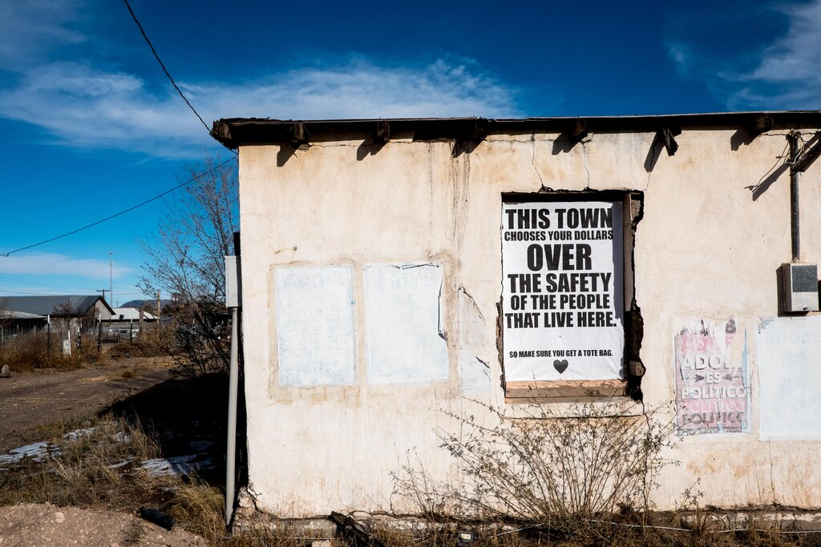

Murals around Marfa have been critical of the town’s coronavirus safety precautions. Joel Angel Juarez for The New York Times

There are a number of reasons for the spike.

The area is so remote that local residents have to travel to El Paso or Odessa for doctor’s appointments and to buy necessities at Walmart. With cases soaring across West Texas, the virus may have traveled back with them. Officials also cited everyday movement to and from Mexico, cases among young people at Sul Ross State University and a surge of tourists undeterred by the pandemic.

Visitation was up 20 percent at Big Bend National Park in October, park officials said, and on Thanksgiving weekend so many cars clogged the park it caused a traffic jam. In the liberal artist outpost of Marfa, young people from Austin and Dallas roam the town, sipping almond milk lattes and photographing murals that ask existential questions like, “Is austerity an illusion?” A recent art installation caused a stir with a blatant message against tourism during the pandemic: “Everyone here hates you.”

But tourism, it turns out, is not the biggest part of the problem.

The area’s limited contact tracing shows more localized spread — in bars, in multigenerational homes and through people who ignore positive test results and continue to work and socialize as normal.

In Alpine, the largest city, with a population of 5,900, residents wear masks with their cowboy hats to shop at Porter’s grocery store, but take them off to eat indoors at restaurants in town. There is far from universal agreement about whether masks are necessary and effective. In a sign of the dispute that has played out on and off social media, the county was left without a local health authority when the doctor in the position, a pediatrician working on a volunteer basis, quit this fall after facing pushback from residents who opposed mask orders and other restrictions.

Brewster County, which includes Alpine, has already instructed bars to close and reduced indoor dining at restaurants from 75 percent capacity to 50 percent, as required by the governor’s order for counties with a high proportion of Covid-19 hospitalizations. But enforcement is spotty, and the governor has barred local officials from imposing rules that are stricter than his own.

With resources scarce, local health clinics are a primary option for testing, but even then, the swabs have to be driven three hours to El Paso and flown for processing in Arlington, outside Dallas. The National Guard also offers periodic testing, and in response to the growing crisis, new mobile testing vans were scheduled to arrive this week.

For those who do get seriously sick, the hospital, Big Bend Regional Medical Center in Alpine, has just 25 beds and a makeshift Covid-19 ward where patients have been sequestered at the end of the lone, L-shaped hallway.

Dr. John Ray, a family practitioner who works shifts at the hospital, said the hospital on one recent day got back-to-back calls about incoming coronavirus patients. One of them had to be transferred to a bigger hospital in Odessa to receive specialized care.

Not long afterward, Dr. Ray said, he saw the patient’s obituary in the paper.

“I don’t want to see Alpine like the pictures you see in New York, just people dying in hallways waiting for a bed,” said Dr. Ray, 44, who grew up in the small East Texas town of Troup, moved to Wisconsin for his residency and returned to Texas afterward, settling in the Big Bend region in 2013 for the beauty and the people. He and his wife, also a doctor, usually treat a caseload of strep throat, urinary tract infections and pregnancy visits. Now, he said, “it’s Covid, Covid, Covid.”

Across West Texas, higher-level care hospitals are also full. El Paso, which was recently so overrun with infection that it brought in mobile morgues, is still recovering from its own virus surge. In Lubbock, as many as 50 percent of beds were recently filled with Covid-19 patients, and on a particularly bad day last week, the city reported that it had run out of hospital capacity altogether.

Dr. Ray fears there may come a day when more seriously ill patients who would normally be transferred elsewhere will run out of options. “To put it bluntly,” he said, “if you can’t go somewhere else, you are going to die here.”

A spokeswoman for the Big Bend Regional Medical Center said that the hospital has had enough room so far, and has added ventilators, oxygen tanks and nurses to prepare for a surge. Of nine patients in the hospital on Wednesday, four had Covid-19.

Still, many remain worried. Simone Rubi, 46, a graphic designer and musician who owns a coffee shop in Marfa, about a 30-minute drive from the hospital in Alpine, hung a poster outside her to-go window summing up the precarious situation in four words: “Small town, no hospital.”

“There will be no place for us to go if we get sick — that’s the bottom line,” she said, sitting on a picnic bench outside her shop on a recent Saturday morning.

“We’d have to drive to Dallas,” said her husband, Rob Gungor, who said he had asthma and had resigned himself to making the nearly eight-hour drive to stay at an Airbnb close to a major hospital if he contracted the virus, to be nearby in case he took a turn for the worse. Like most people in Marfa, which has accepted masks more readily than some other Big Bend towns, he wore a mask even while outdoors.

“Maybe Phoenix,” he added, “because it’s only a nine-hour drive.”

For those who live in even more rural parts of West Texas, navigating the coronavirus spike has come with consequences far beyond the virus itself.

In the border community of Terlingua, there is just one full-service ambulance for 3,000 square miles. Paramedics have on a few occasions had to drive coronavirus patients three hours round-trip to the hospital in Alpine, leaving the region uncovered for other serious emergencies.

“That has always been our draw — it’s an isolated, beautiful, unadulterated landscape,” said Sara Allen Colando, the county commissioner in Terlingua. But with cases rising, the wilderness is also its own kind of peril.

“If they have to take someone with Covid to God knows where, how long is it before that ambulance is back in service?” she said. “Who is going to be there to answer the call?”

https://nyti.ms/3mXpbm6

© The New York Times 2020